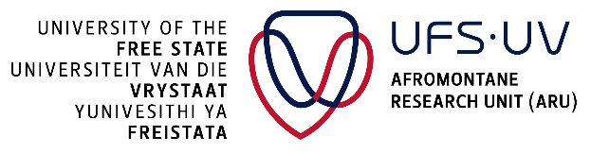
UNIVERSITY OF THE FREE STATE
QWAQWA CAMPUS

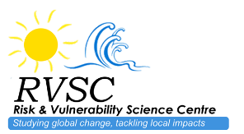
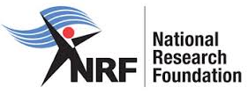
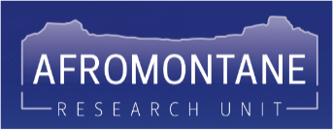

POST-DOCTORAL FELLOWSHIP
UFS-QQ Risk & Vulnerability Science Centre / Afromontane Research Unit

Towards Water Security for Phuthaditjhaba & greater Maloti-a-Phofung Local Municipality (Free State, South Africa): Monitoring High-elevation Wetland Health using Bio-acoustics & Diversity Indices

The Afromontane Research Unit (ARU) is a Strategic Research Hub in the University of the Free State (UFS), and is the flagship research group of the Qwaqwa Campus (UFS-QQ). The vision of the ARU is to become ‘A Continental Leader in African Mountain Research, with an immediate focus on the sustainable development of the Maloti-Drakensberg’.

Freshwater is a critical resource for all life, but Global Change is already severely disrupting existing freshwater supplies. Human-driven landscape degradation, coupled with more frequent and intense weather events from climate change, are affecting the hydrology and physico-chemical characteristics of Strategic Water Source Areas in southern Africa. One of the indicators of these disturbances is local and regional extinction of key freshwater biodiversity in Strategic Water Source areas. As the physical maintenance of water production ecological infrastructure is supported by diverse functional communities, reduced aquatic biodiversity further exacerbates the threats posed by Global Change. Traditional assessments of water quality and habitat health require intensive fieldwork and expert knowledge, making consistent monitoring. At the same time, scientists emphasize the need for better monitoring of our watersheds, particularly in the highlands where much freshwater originates, and in isolated, vulnerable habitats such as islands.

Through its Risk & Vulnerability Science Centre (RVSC), the ARU seeks to develop an Acoustic Water Quality Index using passive bio-acoustic monitoring to monitor the quality of high-elevation wetlands in Maloti-a-Phofung Local Municipality (Free State Province). As the acoustic landscape of montane / high-elevation wetlands remain poorly documented and understood, this research will yield highly original biological data, while also creating a novel monitoring paradigm that has the potential to improve the resilience and management of our Strategic Water Source Areas.

This project is part of a collaboration with BirdLife South Africa (Dr Kyle Lloyd – Rockjumper Fellow of White-winged Flufftail Conservation), the Leibniz Institute for Analysis of Biodiversity Change (Dr Nicholas Friedman – Curator of Ornithology), and the National University of Lesotho (Dr Peter Chatanga – Senior Lecturer & Head of Department of Biology and Biotechnology).

The ARU is seeking a self-led, physically fit, Post-Doctoral Fellow to coordinate the High-elevation Wetlands Bio-acoustics programme, through:
- Managing existing field-sites and expanding to new suitable sites in Maloti-a-Phofung Local Municipality.
- Being the primary actor between the four Partners.
- Develop an Acoustic Water Quality Index.
- Supervising post-graduate students.
- Contributing to funding proposal applications.

In addition to the above, the Fellow will also have the opportunity to be exposed to and contribute to the wide range of world-class mountain-related activities being driven by the ARU.

FELLOWSHIP DETAILS
- One year with the option of renewing for a second year, depending on performance.
- The Fellowship is valued at ZAR220,000.00 for one year (12 months) with R50,000.00 for running costs.

ELIGIBILITY CRITERIA
- A PhD degree in a relevant background discipline (e.g. Ecology, Zoology, or motivated other).
- Applicants should have obtained their Doctoral degree within five (5) years, or can show proof of pending graduation in 2021.
- Applications from South African and international candidates are welcomed.
- Candidates may not hold full-time salaried employment during the tenure of the award.
- Valid passport (as this is a transboundary area).
- Valid drivers’ license.
- Proficiency in English, both verbal and written, is required.
- The following intellectual/experience background will be an advantage:
  - Analyses of complex datasets using multivariate statistics in the R statistical environment, and use of Kaleidoscope software, machine learning, and passive acoustic monitoring equipment.
  - Conservational in Sesotho and Afrikaans.
  - Familiarity with southern African grassland and wetland bird diversity.

APPLICATION REQUIREMENTS
- Motivation Letter (1 page).
- Full Curriculum Vitae (CV) (including a list of academic outputs to date).
- Full transcripts of academic record.
- Copy of degree certificates.
- Copy of South African identity document or Passport (international candidates).
- Signed letters of recommendation from three academic references.

Short-listed candidates will be interviewed by telephone/MS Teams. Applicants who do not hear any response to their application by 30 October 2022 can assume that they have not been successful. The UFS reserves the right to re-advertise for this post if a suitable candidate is not found.

Application Deadline: 30 September 2022

Contact Person:
Prof. Aliza le Roux
Associate Professor: Department of Zoology & Entomology; Afromontane Research Unit
University of the Free State: QwaQwa Campus
Private Bag X13, Phuthaditjhaba, 9866, South Africa
Email: lerouxa3@ufs.ac.za

